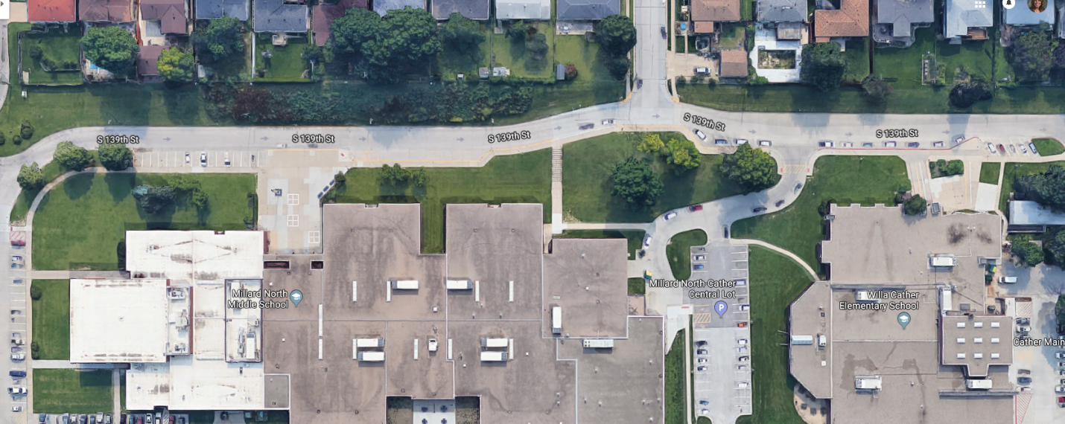

NMS

**Drop Off Zone**

Cather

**Drop Off Zone**

NMS Families with Cather Students

Follow the **RED** arrows

Cather Families without NMS Students

Follow the **BLUE** arrows

NMS Families without Cather Students

Follow the **YELLOW** arrows